27.30: To pass undeflected in both cases,
a) If 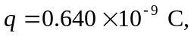 the electric field direction is given by 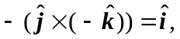 since it must point in the opposite direction to the magnetic force.
b) If 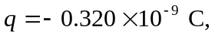 the electric field direction is given by 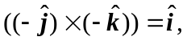 since it must point in the same direction as the magnetic force, which has swapped from part (a). The electric force will now point opposite to the magnetic force for this negative charge using 